Facultative plagiarism check
Log in in Blackboard (lms.uantwerpen.be) with your student account (don't access the tool via the student portal !)
(I log in with my teacher account: see below)
Go to Organisations and search the organisation UA_SP_ICT_EN
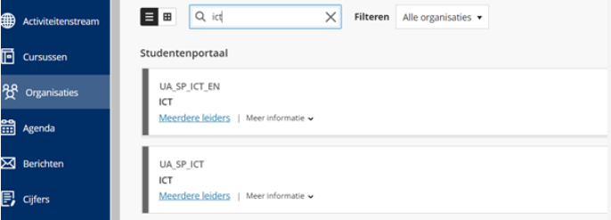
Click on the organisation ICT_EN and go to Digital learning environment: Blackboard.
Click on “How to use Blackboard?”

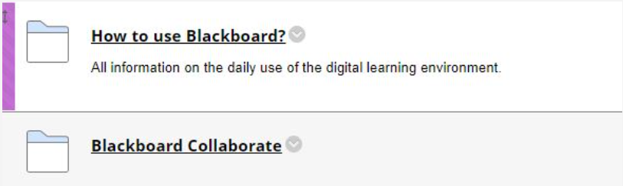
At the bottom of the page you find: “Completely facultative plagiarism control via SafeAssign”.
Click on the title and follow the instructions.

