LEARNING AGREEMENT FOR STUDIES

(.
Student | Last name (s) | First name (s) | Date of birth | Nationality | !Sex[M/F] | Study cycle | Field of educatio
Student |  |  |  | Netherlands | Female | Master | Pharmacy, 12.5
Sending Institution | Name | Faculty/Department | Erasmus code (if applicable) | Address | !Country | Contact person name; email; phor
Sending Institution | UNIVERSITEIT ANTWERPEN | Faculty of Pharmaceutical, Biomedical and Veterinary Sciences | B ANTWERPOl | Prinsstraat 13 BE-2000  Antwerpen Belgium | Belgium,B! | Demuynck, Miep, ,  +323 2652763/ miep.Demuynck@uantwerpen.be
Receiving Institution | Name | Faculty/ Department | Erasmus code (if applicable) | Address | 1Country | Contact person name; email; phor
Receiving Institution | UNIVERSITY OF LIVERPOOL | Department of Chemistry | UK LIVERPOOl | Crown  Street, Liverp ool L69 7ZD | United Kingdom,UK

Section to be completed BEFOR E TH E MOBILITY
Planned period of the mobility: from 09/2018 till 12/2018 Table A ·Studv programme at the receiving institution
Component code (if any) | Component title (as indicated in the course catalogue) at the receiving institution | Semester | Number of ECTS credits to be awarded by the receiving institution upon successful completion'
 | Ma ste rproef: stage in farmaceutisch onderzoek en ontwikkeling | autumn
 |  |  | Total: N/A

Web link to the course catalogue at the receiving institution describing the learning outcomes:

Table B· Recognition at the Sending Institution

. .
Component code (if any) | Component title (as indicated in the course catalogue) at UAntwerp | Semester | Number of ECTS credits to be recognised by UAntwerp
1001FBDfGO | Masterproef: stage in farmaceutisch onderzoek en ontwikkeling | autumn | 27,00
 |  |  | Total: 27,00

..
If the student does not complete successfully some educational components, the followmg prov1s1ons Will apply: The prav1s1ons can be found 1n the "student
mobility regulations" available in each faculty . Please contact the international coordinator for mare info.
Language competence of the student:
The level of language competence in English [main language of instruction] that the student already has or agrees to acquire by the start of the study period is:
Al 0 A2 0 Bl 0 82 0 Cl 0 C2.
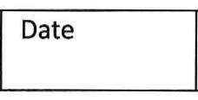For the Common European Framework of Reference for Languages (CEFR) see http://europass.cedefop.europa.eu/en/resources/european-language-levels-cefr

Commitment Name Email Position Signature

In case of thesis research/doctoral work at the receiving institution, the component "thesis research" or "doctoral work" will be included in Table A. If no ECTS credits are provided by the receiving institution, it is sufficient to write "not applicable" in that column. The thesis/doctoral work and the associated workload in ECTS credits will be included in Table B, if relevant for the sending institution.

By signing this document ,the student, the Sending Institution and the Receiving Institution confirm that they approve the Learning Agreement and that they will comply with all the arrangements agreed by all parties. Sending and Receiving Institutions undertake to apply all the principles of the Erasmus Charter for Higher Education relating to mobility for studies (or the principles agreed in the Inter-Institutional Agreement for institutions located in Partner Countries). The Sending Institution and the student should also commit to what is set out in the Erasmus+ grant agreement. The Receiving Institution confirms that the educational components listed in Table A are in line with its course catalogue and should be available to the student. The Sending Institution commits to recognise all the credits gained at the Receiving Institution for the successfully completed educational components and to count them towards the student's degree as described in Table B. Any exceptions to this rule are documented in an annex of this Learning Agreement and agreed by all parties. The student and the Receiving Institution will communicate to the Sending Institution any problems or changes regarding the·study programme,responsible persons and/or study period.

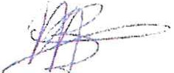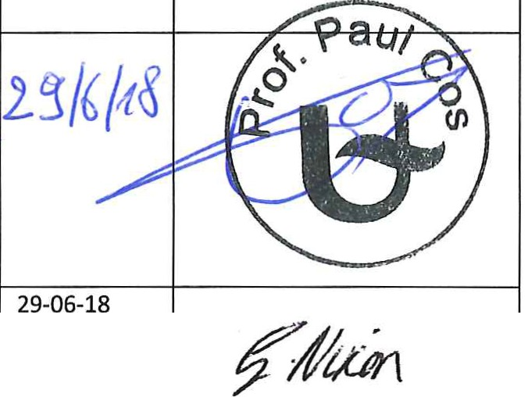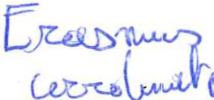
Student |  |  | Student | 29-06-2018
Responsible person at  the sending institution | 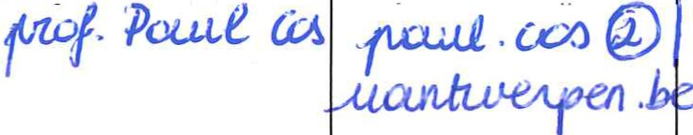 |  |  | 29-06-2018
Responsible person at the receiving institution |  |  | Lecturer in Medicinal Chemistry | 29-06-2018

By signing this document, the student, the Send ing Institution and the Receiving Institution confirm that they approve the Learning Agreement and that they will comply with all the arrangements agreed by all parties. Sending and Receiving Institutions undertake to apply all the principles of the Erasmus Charter for Higher Education relating to mobility for studies (or the principles agreed in the Inter-Institutional Agreement for institutions located in Partner Countries) . The Sending Institution and the student should also commit to what is set out in the Erasmus+ grant agreement. The Receiving Institution confirms that the educational components listed in Table A are in line with its course catalogue and should be available to the student. The Sending Institution commits to recognise all the credits gained at the Receiving Institution for the successfully completed educational components and to count them towards the student 's degree as described in Table B. Any exceptions to this rule are documented in an annex of this Learning Agreement and agreed by all parties.The student and the Receiving Institution will communicate to the Sending Institution any problems or change s regarding the study programme, respons ible persons and/or study period.

